Library Scavenger Hunt

Library of Congress Classification System (LC System)

The U.S. Library of Congress assigns a call number to every item it catalogs, and that number is then used in most scholarly libraries in the United States. If you grow accustomed to the classification system, you can predict (roughly) what a call number will be for certain books. And once you know a book’s call number, you should be able to locate it in about any library you visit (assuming that the library owns it).
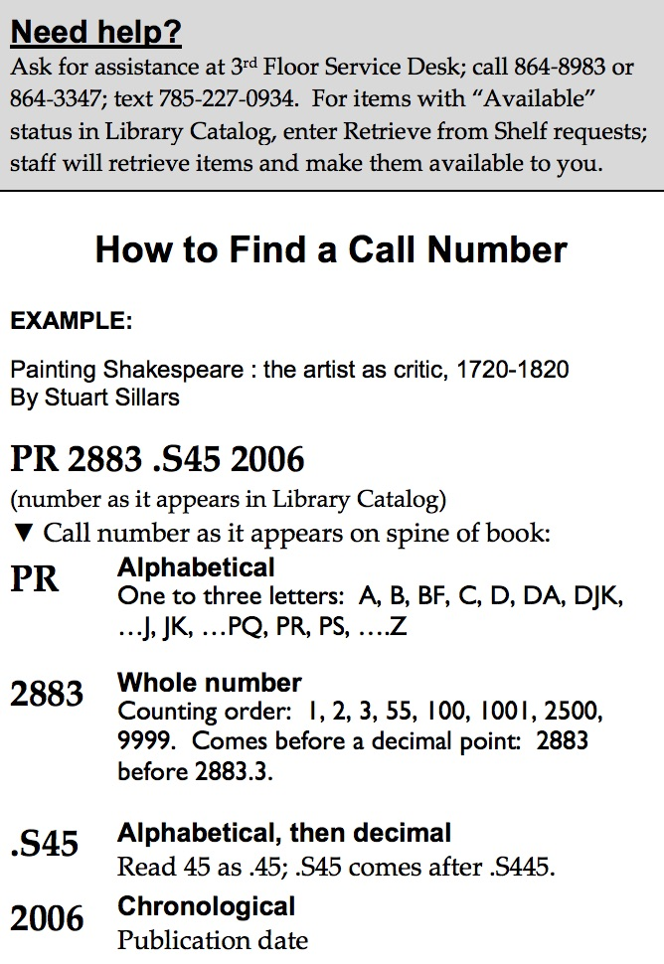
At KU, we have a variety of libraries for different types of research, but they all use the LC system to sort their collections. As undergraduates, the main two libraries you will use will (probably) be Watson or Anschutz Libraries. In particular, Watson Library is the home for social sciences, humanities, education, journalism, and social welfare. Watson Library is particularly tricky because of its use of wings and half stacks, which makes it an ideal place to practice using the LC system.
We will practice using the LC system by examining a section of the library stacks. The LC System sorts books by subject and uses subject headings to separate the collection. (Once you become specialized in an area of study, you’ll find yourself often returning to a similar section of the library.) Don't worry about memorizing the subject headings - I just want you to know how librarians organize information. We'll start our scavenger hunt with the English literature section, which starts with PR.

The PR Section
We begin our search on the main floor of Watson library, 3rd floor Center. The first step is to go to the section of the library where the “PR” books are located. Just look at the guide near the stairwells for an indication of where (what floor and wing) the PR books are located. Go to that floor and wing next.

Once you’re on the right floor and wing, find the beginning section of the PR books. Look for PR books with the very lowest number (PR 21) and start scanning the books that appear first. Do you see that this early section (PR 21-1000) has general literary histories? It also has histories that focus on particular genres or authors.

Go to PR 871. What genre of literature do you find here? Skim a few books that have this call number (look at the table of contents, for example) and describe briefly what that genre is like (is it long or short, is it prose or poetry, etc…):

Now walk the stacks until you come to PR 1580. This is where we finally come to literary texts and specific criticism about those texts. It begins here and continues for the rest of this wing. You are currently in the Medieval and Renaissance English literature section. Do you see the title of any book from Old English Literature that seems familiar to you? Name it here:

You are also now at the point where books are categorized by their authors. The books are alphabetical by the author’s last name. (If some seem out of order it is because people sometimes use pseudonyms, but LC uses their real names.)

Gradually move down and then to the right until you have found these names; then put down the call number. (It is OK just to give the portion of the call number that is common to all the books by that author):

Geoffrey Chaucer: __________________________

John Donne: _______________________________

William Shakespeare: _____________________________

Stop for a few minutes at Shakespeare. There are many volumes by and about him and his works. Do you see all the multi-volume sets from the 19th century? (They are bound in a medium-brown, really-old leather.) Look inside a volume; do you really want to read this? No way! We keep this set because of its historical importance, but if you really want to read a Shakespeare text, be sure to use a much newer set of his works, say the Norton Critical Edition of the Complete Works. Write down the call number for a new edition of Shakespeare’s complete works.

You can also find individual copies of most plays. See if you can locate a new copy of Hamlet. Write down the call number for that particular copy.

Now keep walking through the increasing call numbers, looking always for the alphabetical progression. When you get to the end of a shelf go around to the other side. Keep scanning the author names (slowly) until you get to the end of the alphabet for the Medieval and Renaissance section.

Who is the last author in Medieval and Renaissance section? __________________

After this author, the alphabet restarts at A again! Why?

What has happened is that the alphabet has started over again, but this time with more recent authors (18th and 19th century). Find the following authors in this set of names in alphabetical order, and write down the section of the call number that is always associated with that author’s name:

Jane Austen: ________________________________

Anne, Charlotte, and Emily Brontë: _______________________

Charles Dickens: _____________________________

John Keats: ________________________________

Oscar Wilde: ________________________________

Find your way to the end of the alphabet (and to one of my favorite poets), W.B. Yeats. What is his call number? __________________________________

You’ll notice that shortly after Yeats the alphabet begins again, but now with 20th century authors.

This new section begins on this floor and wing, but there are too many books, so the rest are located on the next half-floor. Head on up the stairs and all the way to the left to find these 20th century authors’ call numbers.

Joseph Conrad: _______________________________

James Joyce: _________________________________

Virginia Woolf: _________________________________

Now the alphabet begins again (for the final time) into very recent English authors and their works. This final section also includes authors from some of the British Commonwealth countries – Scotland, Ireland, Canada, Australia, and New Zealand. After the PR section ends, we transition into the PS section, which is the home of American literature.

Your final task for this exercise is to return to PR section, and to write down the titles and call numbers of two books that you think might be useful or interesting to you at some time in the future.

